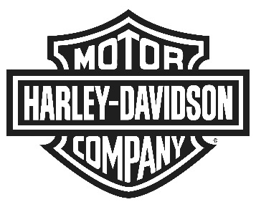
Harley-Davidson Europe Ltd
6000 Garsington Road, Oxford, OX4 2DQ, United Kingdom
NEWS

EMBRACE THE REBEL INSIDE WITH THE NEW HARLEY-DAVIDSON BLACK LABEL COLLECTION

- Authentic motorcycle cool meets trend-forward spring collection -

OXFORD (April. 13, 2015) – With the arrival of spring, Harley-Davidson has today unveiled its latest Black Label Collection, designed to provide style, toughness and comfort for the new generation as they explore their own destinations. There is a discreet, minimalist new look and feel to the collection as well as an increase in the number of product lines available.

The Harley-Davidson Black Label Collection is created for those who truly embrace their individuality and strive to live life to the fullest. The products from the collection are simplistic and modern while still retaining the legendary attitude of Harley-Davidson. The world is not something to live within, it is something to explore and experience and the Harley-Davidson Black Label Collection lets you set the rules and live life by them.

Harley-Davidson Black Label Spring Collection: Minimalistic Detail | Iconic Design

Following on from previous successes, the collection continues to push the envelope with contemporary, groundbreaking designs. The men’s spring collection features designs grounded in the Harley-Davidson DNA of leather, metal, rubber and iconic symbols; pops of orange break up this ‘Harley attitude’ with a muted colour palette. Never stop exploring with the lightweight Washed Lambskin Leather Jacket featuring a unique washed and waxed finish for a one-of-a-kind distressed appearance.

Bring your own style, live it your way and do it on your terms with the women’s spring collection. This features mixed materials, textures and tonal graphics that translates an authentic, motorcycle look into contemporary clothing including jackets, tanks, hoodies, knits and woven tops. The collection includes a full line of apparel and accessories with small badges and emblems to retain the rebellious, dynamic nature of the Harley-Davidson brand. Show your independence with the mid-weight Overdyed Goatskin Leather Biker Jacket featuring a distinctive teal base colour over dyed with black creating a signature distressed finish.

Familiar offerings such as the vintage Iconic Tee selection are now folded into the seasonal collections for both Men and Women and are available in V-neck, crew-neck, muscle Tee and Tank styles. Tee and Tank graphics are inspired by neon signs, color stained graphics and eagle iconography.

All items can be purchased at your local Harley-Davidson dealership. For more information about the collection, visit www.Harley-Davidson.eu/motorclothes.

---

About Harley-Davidson Motor Company®
Harley-Davidson Motor Company® produces custom, cruiser and touring motorcycles and offers a complete line of Harley-Davidson motorcycle parts, accessories, riding gear and apparel, and general merchandise. For more information, visit Harley-Davidson's website at www.h-d.com.

